
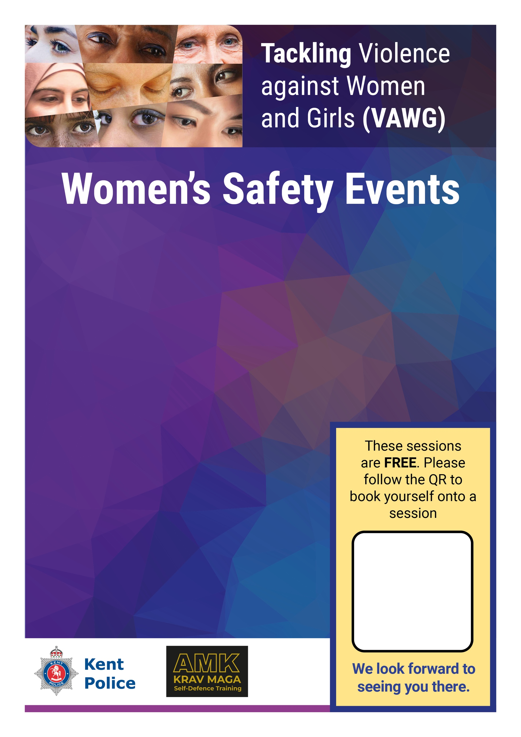
On the following dates:
- Monday 24 November 2.30pm-5.30pm
- Monday 1 December 2.30pm-5.30pm
This will be an active event please dress comfortably

Kent Police are committed to eradicating all forms
of violence against women and girls.
We want all women and girls who live, work, socialise and attend schools in our communities to feel safe.
Kent Police in partnership with AMK Krav Maga – Self defence experts and Rock Solid – Health Wellbeing Transformation practitioners are running several self-defence sessions with partner agencies, ending with a walk and talk within the community. Join us!


Location: Deal Town Hall, High Street, Deal CT14 6TR

